Course Outline
Course: M.Forst.757: Bodenmikrobiologische Übung. / Field Practical on Soil Microbiological Processes
Credits: 9 credits, grade based on practicum participation and written scientific report
Language: German and English
Degree level: Masters
Duration: Aug. 3-14, 2026; Time: 8:30-12:00 and 13:00-16:00 daily
Report deadline: Sept. 11, 2026 (register on FlexNow)
Number of students: limited to 20 students
Lecturers: Dr. Marife D. Corre and Dr. Guntars Martinson
Course Objectives:
- To understand the principles and carry out measurements of soil physical and biochemical characteristics (bulk density, soil water content, pH, soil organic C, total N, cation exchange capacity, plant-available P and microbial biomass) and microbial processes (asymbiotic N₂ fixation and soil greenhouse gas fluxes)
- To assess the differences in soil biochemical characteristics and microbial processes between a cropland agroforestry and a beech forest
- To learn basic R statistical analysis and on how to write a scientific report
Sites:
Cropland agroforestry and forest sites. The agroforestry site is an alley planting structure of crop rows alternated with rows of fast-growing willows and poplars (used for biofuel); measurements will be conducted on the tree row and crop row. The forest site has mature beech, and serves as the reference site, being the prior land use of the converted cropland at present; measurements will be conducted on the upper and lower slopes. In each stratified sampling unit (tree and crop rows, and upper and lower slopes), there will be 5 sampling points, spaced at least 15 m, serving as replicates.
Part 1. Soil physical and biochemical characteristics
Measurements of bulk density, soil water content, pH, soil organic C, total N, cation exchange capacity, plant-available P and microbial biomass. Data calculations.
Part 2. Asymbiotic N₂ fixation
Measurements of asymbiotic N₂ fixation. Data calculations.
Part 3: Greenhouse gases from soils
Measurements of soil CO₂, N₂O and CH₄ fluxes from the soils. Normally, soils emit (+ flux) CO₂ from root and microbial respiration and N₂O from nitrification and denitrification. CH₄ is normally consumed in the soil (- flux) by methanotrophic bacteria. In saturated microsites or anaerobic conditions, however, CH₄ is produced by archaea. Thus, the soil-surface GHG fluxes (CH₄ and N₂O) are the net balance between emission and uptake of these gases within the entire soil. Data calculations.
Site characteristics:
Characteristic | Agriculture | Forest
Location coordinates | 51.5662° N, 9.9525° E | 51.5645° N, 9.9640° E
Landscape position | Mid-slope | Upper and lower slopes
Land use | Alley cropping: poplar/willow trees (planted in 2011; 1st cut in Jan. 2017; 2nd cut in Feb. 2025) and annual crops | beech
Soil type  (KA5: German soil classification system) | Parabraunerde | Parabraunerde
Soil type  (WRB: World Reference Base) | Cambisol | Cambisol
Parent material | Loess over Triassic limestone | Loess over Triassic limestone
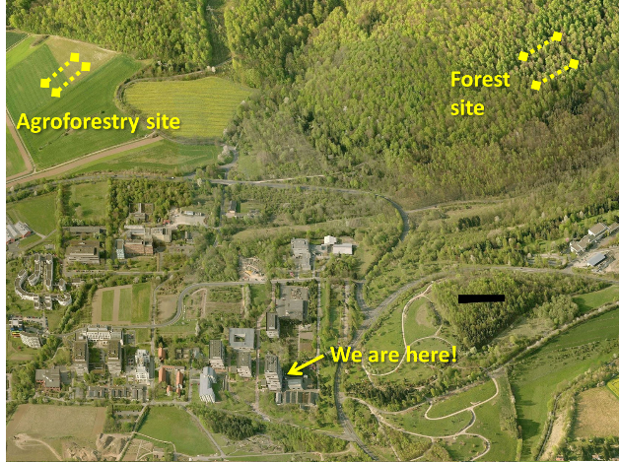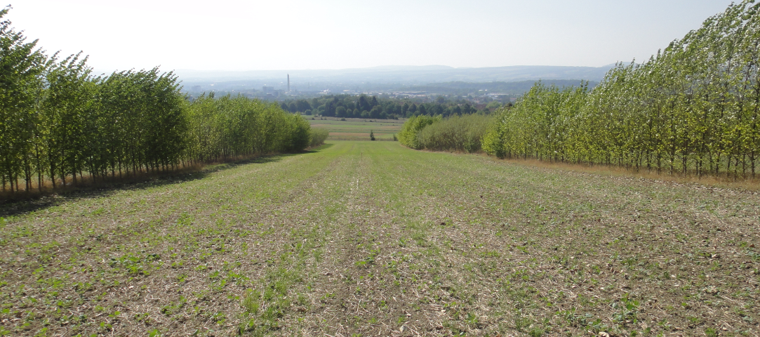
Schedule of activities M.Forst.757: Bodenmikrobiologische Übung. / Field Practical on Soil Microbiological Processes
 | Monday | Tuesday | Wednesday | Thursday | Friday
1st week  Aug. 3-7  8:30 | Part 1:  Introduction of the course, SOC and N measurement, field sampling of soils for microbial biomass and taking intact soil cores for bulk density & N₂ fixation  Corre & Martinson  Room FSR 2.3 | Part 2:  Introduction to asymbiotic N₂ fixation & start of analysis  Martinson  Cont. part 1. . .  Introduction on plant-available P & start analysis  Corre/Sandesh  Room FSR 2.3 | Cont. part 2 . . .  Asymbiotic N₂ fixation, oven dry the soils,  principles of C₂H₄ analysis, and GC orientation for C₂H₄ analysis  Martinson  Room 4.115  Cont. part 1. . .  Continuation of plant-available P  Sandesh  Room 3.111 | Cont. part 1. . .  Continuation of plant-available P  Sandesh  Room 3.111  Orientation on ICP, mineral N, DOC analytical instruments  Corre  Room 3.111  Cont. part 1. . .  calculation of plant-available P | Part 3:  Introduction to soil CO₂, N₂O and CH₄ fluxes  Martinson  Room FSR 2.3  Cont. part 3…  Field measurement of soil CO₂, N₂O and CH₄  Corre & Martinson
13:00 | Cont. part 1. .  start of fumigation for soil microbial biomass, extraction of C and mineral N from unfumigated soils, soil water content, bulk density. Place fresh samples in the fridge for P analysis.  Corre & Martinson | Cont. part 1. . .  Continuation of soil water content & drying stone  Corre & Martinson  Cont. part 2 . . .  Asymbiotic N₂ fixation  Martinson  Room FSR 2.3 | Cont. part 1. . .  principles of CN analyzer, orientation on soil prep. for SOC and N, orientation of CN analyzer  Martinson  Cont. part 1. . .  Calculation of soil BD, SOC and total N stocks, moisture content, microbial biomass  Corre & Martinson  Room FSR 2.3 | Cont. part 2 . . .  Weigh dry soils from asymbiotic N₂ fixation,  calculation soil water content, dry mass of soil  Corre & Martinson  Room FSR 2.3  Check GC data of C₂H₄ analysis of N₂ fixation  Martinson | Calculation of asymbiotic N₂ fixation  Martinson  Room FSR 2.3

2nd week  Aug. 10 – 14  8:30 | Cont. part 1:  Introduction to effective cation exchange capacity, and start analysis; soil pH  Corre/Schröder/Langs  Room FSR 2.3 and 3.111  Check GC data of CH_{4,} CO₂, N₂O analysis  Martinson | Cont. part 3:  Calculations of soil CO₂, N₂O and CH₄ fluxes  Martinson  Room FSR 2.3  Data format prep for stat analysis in R  Martinson  Room FSR 2.3 | Cont. part 1:  Calculations of effective cation exchange capacity  Corre  Room 2.3  Part 4:  Statistical analysis in R using the data from the practicum. | Cont. part 4:  Statistical analysis correlation, e.g. N2 fix vs WFPS…  Soil GHG vs WFPS, soil temp…..  Martinson  Room FSR 2.3 | Cont. part 4:  Students do literature research on land-use change and agroforestry in temperate area and in Germany
13:30 | Extraction of fumigated soil  Corre  Room FSR 2.3  Gas chromatograph orientation & sample analysis  Martinson  Room 4.115 | Cont. part 1:  Continuation of effective cation exchange capacity  Schröder  Room 3.111 | Part 4:  ANOVA or Kruskal-Wallis; Fisher’s LSD or multiple comparison extension  Martinson  Room FSR 2.3 | Cont. part 4:  Report format discussion  Corre  Statistical analysis Martinson  Room FSR 2.3 | Start writing report: Introduction -Methodology

