Looking for Students – Master Thesis and Internships

Traceability in Forest and Sawmill Environments

Summer 2026 at NIBIO in Ås, Norway
The European Union Deforestation Regulation (EUDR) requires transparent traceability of timber from the harvest site to the final wood product. Developing reliable digital traceability systems is therefore becoming a key challenge for the forestry and wood industry.
At the Norwegian Institute of Bioeconomy Research (NIBIO), research focuses on new technologies that enable tracking of sawlogs and wood products throughout the value chain — from forest harvesting to industrial processing. This project explores how computer vision, sensors, and machine learning can be used to create robust traceability solutions for real forestry and sawmill environments.
Motivated students in Forestry, Wood Technology, Computer Science, or related fields with an interest in data science and AI are invited to join this research. The project offers hands-on experience with real industrial datasets, modern sensing technologies, and applied machine learning in collaboration with researchers at NIBIO.
The project may include several research directions:
• (1+2) Detection and decoding of printed identification codes on sawlog cross-sections using computer vision
• (3) Classification of side-product quality using image-based machine learning methods
• (4) Extraction of geometric features from sensor data (e.g., 3D scanning or LiDAR) for log identification and traceability
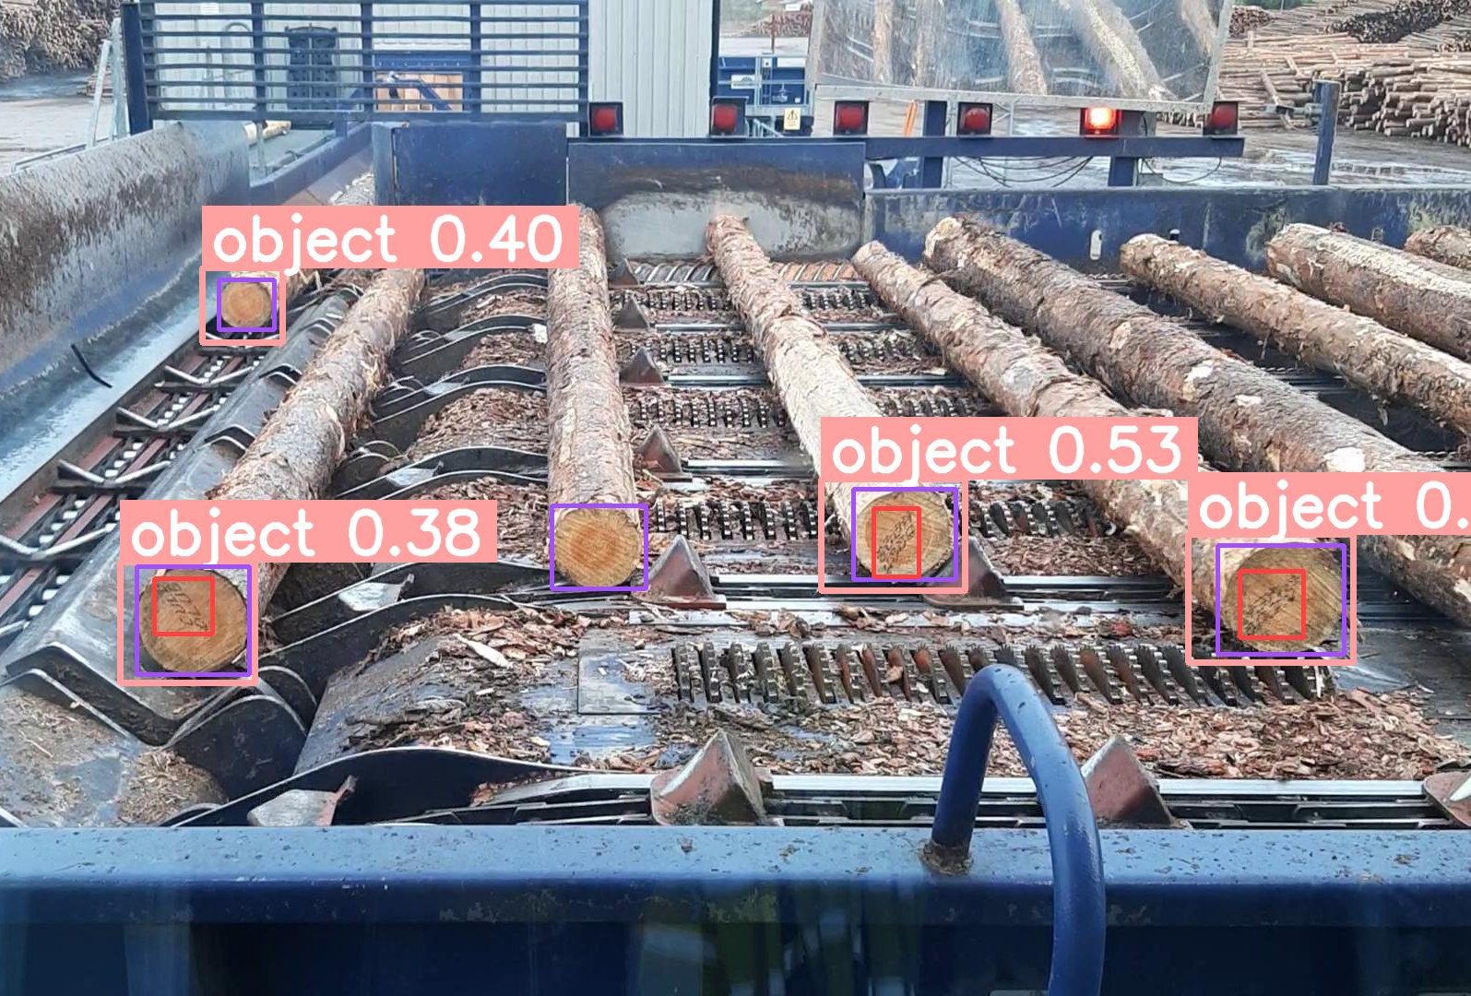 | 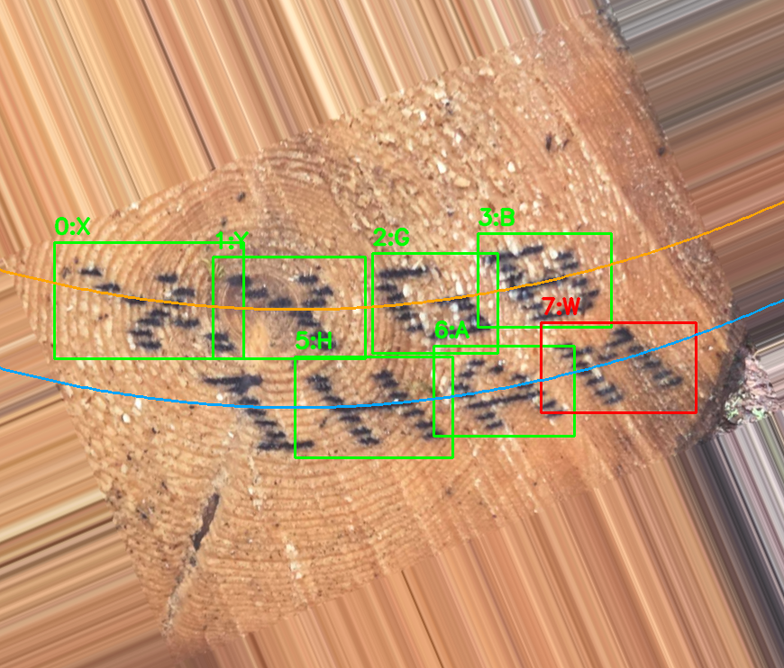 | 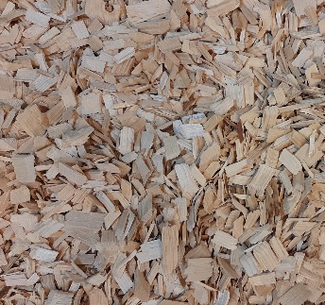 | 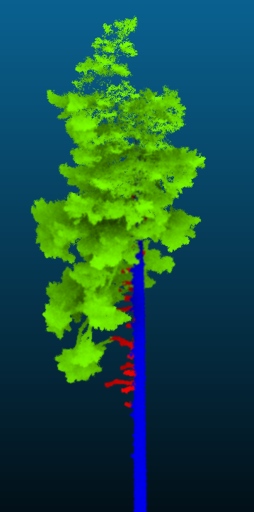
(1) | (2) | (3) | (4)
Possible student tasks
• Literature review on timber traceability, computer vision, and sensing technologies in forestry
• Field data collection using digital camera systems and/or LiDAR sensors
• Data processing and analysis using machine learning or image analysis techniques
• Contribution to a scientific publication (co-authorship or corresponding author)
The project offers an opportunity to work with real industrial problems, modern research tools, and a collaborative research team in a supportive and low-hierarchy environment.
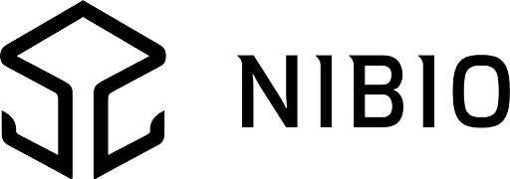
Students are encouraged to take ownership of their project idea and actively shape the research direction. Working language is English but support can be provided in German.
Interested students are welcome to contact
Alexander Scharf — alexander.scharf@nibio.no

