Dear students and doctoral candidates,
Are you starting a study-related stay abroad (not as part of ERASMUS+) between 1 July and the end of 2026? Then you have the opportunity to apply for a PROMOS scholarship from 1 February to 31 March 2026.
Eligible measures are
- Study visits by students (1 - 6 months funding duration, no funding for stays in Erasmus+ programme countries; stays in the United Kingdom can be funded)
- Stays abroad by students to complete their final thesis (1 - 6 months funding duration)
- Internships for students (4 weeks to 6 months funding duration; no funding for stays in Erasmus+ programme countries)
- Language courses for students and doctoral candidates (3 weeks to 6 months funding duration)
- Specialised courses for students and doctoral candidates (5 days to 6 weeks funding duration)
For detailed information, including the exact selection criteria, please refer to the guidelines on the homepage http://www.uni-goettingen.de/promos where you will also find the link to the application portal.
Please note that PROMOS funding is very limited and only a small number of applicants can be funded. Successful applications will receive a one-off mobility instalment. You can view the country-specific amount on the homepage. Please take this into account in your planning.
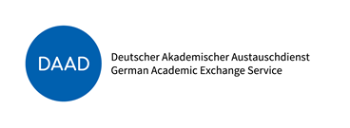
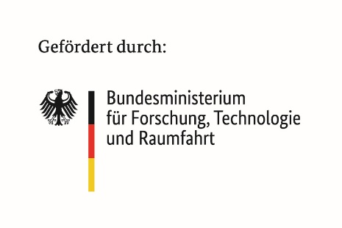
If you have any questions, please feel free to contact patrick.lajoie@zvw.uni-goettingen.de at any time

