Dear students and doctoral candidates,

Are you starting a study-related stay abroad (not as part of ERASMUS+) between 1 January and the end of June 2026? Then you have the opportunity to apply for a PROMOS scholarship from 1 August to 30 September 2025.

Eligible measures are

* Study visits by students (1 - 6 months funding duration, no funding for stays in Erasmus+ programme countries; stays in the United Kingdom can be funded)
* Stays abroad by students to complete their final thesis (1 - 6 months funding duration)
* Internships for students (4 weeks to 6 months funding duration; no funding for stays in Erasmus+ programme countries)
* Language courses for students and doctoral candidates (3 weeks to 6 months funding duration)
* Specialised courses for students and doctoral candidates (5 days to 6 weeks funding duration)

For detailed information, including the exact selection criteria, please refer to the guidelines on the homepage <http://www.uni-goettingen.de/promos> where you will also find the link to the application portal.

Please note that PROMOS funding is very limited and only a small number of applicants can be funded. Successful applications will receive a one-off mobility instalment. You can view the country-specific amount on the homepage. Please take this into account in your planning.

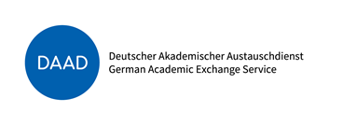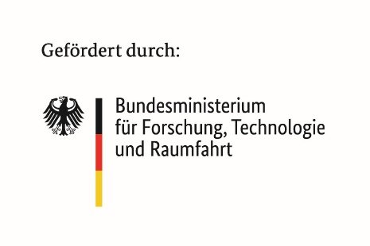  
If you have any questions, please feel free to contact patrick.lajoie@zvw.uni-goettingen.de at any time