Course Outline

**Course:** M.Forst.757: Bodenmikrobiologische Übung. Vorankündigung/ Field Practical on Soil Microbiological Processes

**Credits:** 9 credits, grade based on practicum participation and written scientific report

**Language**: German and English

**Degree level:** Masters

**Duration:** Aug. 11-22, 2025; **Time:** 8:30 and 13:00-16:00 daily

**Report deadline:** Sept. 30, 2025

**Number of students:** limited to 20 students

**Lecturers:** Dr. Marife D. Corre and Dr. Guntars Martinson

**Course Objectives:**

1. To understand the principles and carry out measurements of soil physical and biochemical characteristics (bulk density, soil water content, pH, soil organic C, total N, cation exchange capacity, plant-available P and microbial biomass) and microbial processes (asymbiotic N2 fixation and soil greenhouse gas fluxes)
2. To assess the differences in soil biochemical characteristics and microbial processes between a cropland agroforestry and a beech forest
3. To learn basic R statistical analysis and on how to write a scientific report

**Sites:**

Cropland agroforestry and forest sites. The agroforestry site is an alley planting structure of crop rows alternated with rows of fast-growing willows and poplars (used for biofuel); measurements will be conducted on the tree row and crop row. The forest site has mature beech, and serves as the reference site, being the prior land use of the converted cropland at present; measurements will be conducted on the upper and lower slopes. In each stratified sampling unit (tree and crop rows, and upper and lower slopes), there will be 5 sampling points, spaced at least 15 m, serving as replicates.

**Part 1. Soil physical and biochemical characteristics**

Measurements of bulk density, soil water content, pH, soil organic C, total N, cation exchange capacity, plant-available P and microbial biomass. Data calculations.

**Part 2. Asymbiotic N2 fixation**

Measurements of asymbiotic N2 fixation. Data calculations.

**Part 3: Greenhouse gases from soils**

Measurements of soil CO2, N2O and CH4 fluxes from the soils. Normally, soils emit (+ flux) CO2 from root and microbial respiration and N2O from nitrification and denitrification. CH4 is normally consumed in the soil (- flux) by methanotrophic bacteria. In saturated microsites or anaerobic conditions, however, CH4 is produced by archaea. Thus, the soil surface fluxes of these greenhouse gases are the net balance between emission and uptake of these gases within the entire soil. Data calculations.

Site characteristics:

|  |  |  |
| --- | --- | --- |
| **Characteristic** | **Agriculture** | **Forest** |
| Location coordinates | 51.5662° N, 9.9525° E | 51.5645° N, 9.9640° E |
| Landscape position | Mid-slope | Upper and lower slopes |
| Land use | Alley cropping: poplar/willow trees (planted in 2011; 1st cut in Jan. 2017; 2nd cut in Feb. 2025) and annual crops | beech |
| Soil type  *(KA5: German soil classification system)* | Parabraunerde | Parabraunerde |
| Soil type  *(WRB: World Reference Base)* | Cambisol | Cambisol |
| Parent material | Loess over Triassic limestone | Loess over Triassic limestone |

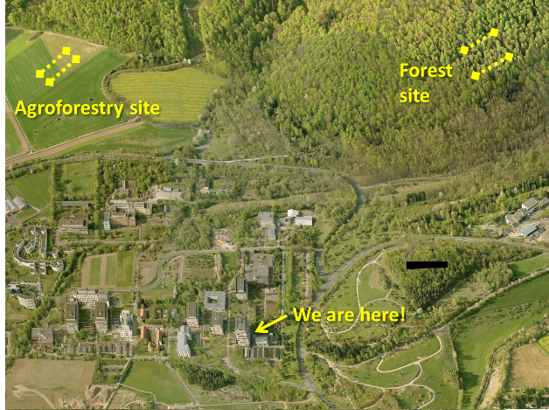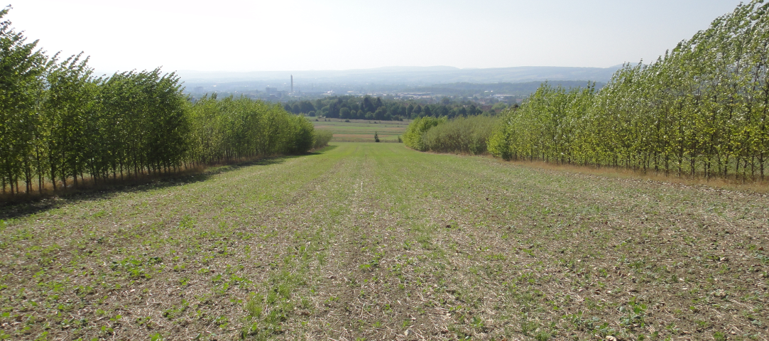

Schedule of activities

|  |  |  |  |  |  |
| --- | --- | --- | --- | --- | --- |
|  | **Monday** | **Tuesday** | **Wednesday** | **Thursday** | **Friday** |
| **1st week**  Aug. 11-15  8:30 | **Part 1:**  Introduction of the course, SOC and N measurement, field sampling of soils for microbial biomass and taking intact soil cores for bulk density & N2 fixation  *Corre & Martinson*  *Room FSR 2.3* | **Part 2:**  Introduction to asymbiotic N2 fixation& start of analysis  *Martinson*  **Cont. part 1. . .**  Introduction on plant-available P & start analysis  *Corre*  *Propa & Martinson*  *Room FSR 2.3* | **Cont. part 2 . . .**  Asymbiotic N2 fixation, oven dry the soils,  principles of C2H4 analysis, and GC orientation for C2H4 analysis  *Martinson*  *Room 4.115*  **Cont. part 1. . .**  Continuation of plant-available P    *Propa & Martinson*  *Room 3.111* | **Cont. part 1. . .**  Continuation of plant-available P  *Propa & Martinson*  *Room 3.111*  Orientation on ICP, mineral N, DOC analytical instruments  *Corre & Martinson*  *Room 3.111*  **Cont. part 1. . .**  calculation of plant-available P | **Part 3:**  Introduction to soil CO2, N2O and CH4 fluxes  *Martinson*  *Room FSR 2.3*  **Cont. part 3…**  Field measurement of soil CO2, N2O and CH4  *Corre & Martinson* |
| 13:00 | **Cont. part 1. .**  start of fumigation for soil microbial biomass, extraction of C and mineral N from unfumigated soils, soil water content, pH, bulk density. Place fresh samples in the fridge for P analysis.  *Corre & Martinson* | **Cont. part 1. . .**  Continuation of soil water content & drying stone  *Corre & Martinson*  **Cont. part 2 . . .**  Asymbiotic N2 fixation  *Martinson*  *Room FSR 2.3* | **Cont. part 1. . .**  principles of CN analyzer, orientation on soil prep. for SOC and N, orientation of CN analyzer  *Martinson*  **Cont. part 1. . .**  Calculation of soil BD, SOC and total N stocks, moisture content, microbial biomass  *Corre & Martinson*  *Room FSR 2.3* | **Cont. part 2 . . .**  Weigh dry soils from asymbiotic N2 fixation,  calculation soil water content, dry mass of soil  *Corre & Martinson*  *Room FSR 2.3*  Check GC data of C2H4 analysis of N2 fixation  *Martinson* | Calculation of asymbiotic N2 fixation  *Martinson*  *Room FSR 2.3* |

|  |  |  |  |  |  |
| --- | --- | --- | --- | --- | --- |
| **2nd week**  Aug. 18 – 22  8:30 | **Cont. part 1:**  Introduction to effective cation exchange capacity, and start analysis  *Corre*  *Room FSR 2.3 and 3.111*  Check GC data of CH4, CO2, N2O analysis  *Martinson* | **Cont. part 1:**  Continuation of effective cation exchange capacity  *Corre*  *Room 3.111*  Calculations of effective cation exchange capacity  *Corre*  *Room 2.3* | **Cont. part 3:**  Calculations of soil CO2, N2O and CH4 fluxes  *Martinson*  *Room FSR 2.3*  Data format prep for stat analysis in R  *Martinson*  *Room FSR 2.3* | **Cont. part 4:**  Statistical analysis correlation, e.g. N2 fix vs WFPS…  Soil GHG vs WFPS, soil temp…..  *Martinson*  *Room FSR 2.3* | **Cont. part 4:**  Students do literature research on land-use change and agroforestry in temperate area and in Germany |
| 13:30 | Extraction of fumigated soil  *Corre*  *Room FSR 2.3*  Gas chromatograph orientation & sample analysis  *Martinson*  *Room 4.115* | **Cont. part 1:**  Continuation of effective cation exchange capacity  *Corre*  *Room 3.111* | **Part 4:**  Statistical analysis in R using the data from the practicum.  ANOVA or Kruskal-Wallis; Fisher’s LSD or multiple comparison extension  *Martinson*  *Room FSR 2.3* | **Cont. part 4:**  Report format discussion  *Corre*  Statistical analysis *Martinson*  *Room FSR 2.3* | Start writing report: Introduction -Methodology |